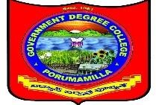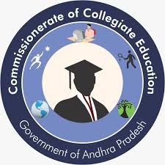**Government Degree College, Porumamilla.**

**Dept of Commerce & Computer Applications**

**Activity- 2021-2022**

|  |  |
| --- | --- |
| **1. Name of the Activity** | **World Aids Day** |
| **2. Name of the Lecturer** | **D.Narasaiah** |
| **3. Date** | **01/12/2022** |
| **4. Number of students participated** | **50** |
| **5. Number of faculty involved** | 10 |
| **6. Aim & Objectives :** To aware the Aids DAy | |
| **7. Brief Report;-**  **NSS & RRC is pleased to conduct an awareness programme in the public by following, procession Manavaharam saying with slogans and ended with pledge. W H O joins partners to mark World Aids Day 2022 under the theme "EQUALIZE". Organized by Commerce & NSS Unit of the college.**                **Signature of the Department in Charge:** | |

|  |
| --- |
|  |
|  |
|  |
|  |
| **Signature of the Department in Charge:** |